Truly Ergonomic CLEAVE Keyboard

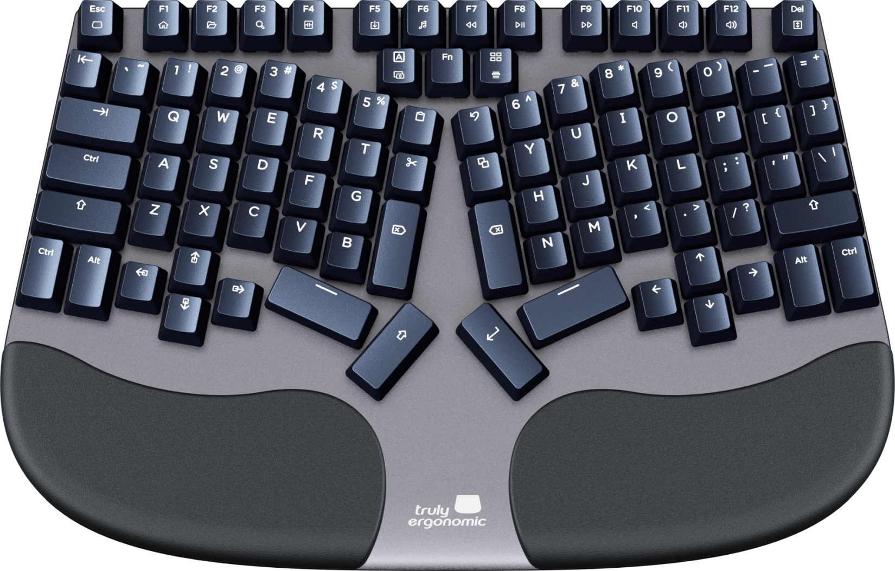

Product Summary 2
Ergonomic Benefits 3
Features 4
Images 6
Technical Specifications 7
Models 8

Product Summary
The CLEAVE keyboard by Truly Ergonomic combines an enhanced ergonomic split design for natural typing with reliable optical mechanical switches, helping achieve a neutral straight wrist alignment and helping increase productivity comfortably.

Conventional keyboards have a layout with rows and a horizontal offset. The CLEAVE keyboard features a columnar layout where each column is adjusted vertically to optimize key positioning by matching the length and reach of each finger and conforming to the natural curvature of the hand. The symmetrical layout encourages a natural ergonomic central positioning of the keyboard reducing fatigue during extended use.

The CLEAVE is the only ergonomic keyboard to incorporate Optical Infrared Mechanical Switches being the most reliable and providing precise tactile feedback that enhances the typing experience.

The integrated palmrest supports made of resilient polyurethane help to reduce wrist extension while providing a soft cushioned rest for the palms. The overall narrow-width keyboard design helps reduce the reach for the mouse by a large margin, significantly lessening the risk of shoulder issues arising from overreach. The included customizable LED backlight provides comfortable white color visibility in any light condition.

Rather than keys being recessed into the housing, the CLEAVE features a base that encloses the PCB and has the keys rising above the machined aluminum housing for a solid and durable feel with effortless cleaning. Most commonly used keys like Backspace, Delete, Shift, and Enter, are positioned centrally to be activated using the strong index fingers and thumbs, further reducing the strain on the weaker pinky fingers.

The CLEAVE keyboard is first and foremost an ergonomically-focused high-performance keyboard with a great ergonomic split design for natural typing, allowing to keep wrists straight, and helping reduce and avoid typing pain. The design follows the body’s natural symmetry and neutral position, conforms to the natural curvature of the hands, and helps reduce fatigue during extended typing sessions, increasing productivity comfortably.

Ergonomic Benefits
Designed for natural typing reducing the risk of wrist injury - Typing on conventional keyboards requires experienced typists to bend the wrists outward toward the little finger in order to keep the fingers in a suitable position for these keyboards. This posture, known as ulnar deviation, puts considerable strain on the joint and tissues of the wrist. The CLEAVE keyboard offers a fixed split layout that aligns the keys to the angle of the hands and facilitates a neutral alignment through the wrists, allowing typing with straight wrists and reducing or even eliminating ulnar deviation.

Columnar layout reduces finger reach - The keys on the CLEAVE keyboard are arranged in vertical columns that reduce the side-to-side movement required on the conventional horizontally-staggered key layout. In addition, because fingers vary in length, each column on the CLEAVE keyboard is also staggered vertically to better match the reach of the corresponding finger.

Increases speed and reduces the load on weaker fingers - The enhanced key layout reduces strain on the pinky fingers by taking advantage of the greater strength of the thumbs and index fingers. The oversized Backspace and Delete keys are positioned centrally to provide instant access by the index fingers. In addition, the Enter key and a supplemental Shift key are also located centrally for quick access by the strong thumbs. This means that the pinky fingers have a reduced load and are no longer stretching to reach for these keys.

Narrow width reduces overreach to the mouse - The CLEAVE keyboard features all the keys in a compact footprint, which combined with an enhanced layout that repositions the navigation keys along other improvements, permits placing the mouse over 5 inches or 12 centimeters closer compared to conventional keyboards. Remarkably reducing the reach to the mouse and enhancing shoulder comfort.

Integrated cushioned palmrest reduces wrist extension - The integrated soft cushioned palm support helps reduce the risk of wrist extension by preventing the wrists from dropping down to the desk or keyboard tray. In addition, the keycaps on the alpha keys have a slight negative inclination to encourage typists to keep their wrists elevated while typing. The keyboard design ensures that when accessing the upper rows of keys, the wrists are able to maintain a neutral alignment.

Features
- Distinctive Fixed Splay: The keys on the CLEAVE keyboard are oriented to closely match the natural hand alignment when reaching in towards the keyboard, allowing to maintain straight wrists while typing.
- Enhanced Key Layout: The CLEAVE keyboard features a superior layout designed to transfer functions for both reduced load on the fingers as well as increased overall performance due to reduced reaching. The Enter key and a supplemental Shift key are located at the center for easy access by the thumbs. The Backspace and a supplemental Delete key are positioned above these and accessible with the index fingers. Above these are dedicated one-touch keys for Cut, Copy, Paste, and Undo - also easily and quickly accessed by the index fingers. Caps Lock, FN, and Windows keys are positioned centrally, between the numeric and function rows. The Page navigation keys are clustered below the left-hand keys, and the directional arrow keys below the right-hand keys. Vertically oriented Ctrl and Alt keys have been placed adjacent to each other in the lower corners of the layout.
- Vertical Column Key Layout: The CLEAVE keyboard features a vertical column grid layout that minimizes finger movement and stretch. The columns are arranged to match the natural differences in finger length, positioning each key within optimal reach.
- Optical-Mechanical Keyswitches: Individual keys are each equipped with laser emitters and sensors for instant actuation. The primary key action remains mechanical with 3 different styles of key to choose from (Tactile, Click Tactile, and Linear). The switches are guaranteed for 100 million keystrokes. Optical switches eliminate the easily-damaged pins present on all conventional mechanical switches. Optical Infrared switches eliminate all the common wear and tear issues that come with all other mechanical switches.
- Compact Footprint: At just 13.6" or 34.5cm in width, the CLEAVE keyboard takes up much less desk space than conventional keyboards, while offering advanced design and function.
- Replaceable and Swappable Switches: Modular and plate mounted Optical mechanical switches offer a quick and easy replacement or swapping. Four extra switches are included per keyboard.
- Dedicated One-Touch Keys: Cut, Copy, Paste, and Undo keys are located centrally for quick and easy access by the index fingers. This eliminates awkward key combinations to speed up editing.
- Enhanced Key Performance: The contact-free optical switches eliminate many of the issues that can arise from wear and tear on conventional mechanical metal contacts. These can include issues such as duplicate key presses, key chattering, oxidation, debouncing glitches, performance degradation, double letters, and missing letters.
- Full-size Keycaps and Spacing: Despite the overall compact dimensions of the CLEAVE keyboard, it uses full-size keycaps and full-size standard spacing between keys.
- Protective Coating: An advanced nano-coating shield makes it water, dust, and even snack resistant. Keycaps are coated with a protective UV coating that defends against oil, grime, and other elements of normal use, keeping them looking perfect and new even after prolonged use.
- Fixed Palm Supports: The CLEAVE keyboard is equipped with integrated palm supports. The sealed polyurethane supports provide a firm but yielding surface and are easily cleaned. They are fully supported and match the natural contours of the palms.
- Cable Routing Options: A cable routing channel in the underside accommodates the cable placement to exit from the right, left, or back.
- Low Profile and Sturdy: The CLEAVE keyboard features a solid, slim profile body made from aerospace grade Aluminum alloy.
- Fully Addressable Backlighting: Bright white addressable and adjustable backlighting is provided by LEDs integrated into the PCB. This means that switches can be swapped out without affecting the backlighting functionality. The CLEAVE keyboard backlighting features 10 brightness levels, 8 customizable backlight profiles, 10 predefined profiles, and 15 backlight effects.
- Programmable Key Options: The split design incorporates dual space bar keys that can be individually programmed to perform separate functions. In addition, the four tall central keys are also programmable.
- 1000Hz Polling: The CLEAVE keyboard features a polling rate that combines with the instant infrared switch activation to accommodate fast typing speeds.
- Onboard Memory: Personalized custom layouts, backlighting settings, and macros are all safely stored in onboard memory for instant access whenever and wherever the CLEAVE keyboard is connected.
- Custom Macro Support: Entering repetitive text or commonly employed complicated commands is easily accomplished by programming these into a single keystroke.
- Anti-Ghosting with Full NKRO: The CLEAVE keyboard is equipped with 100% Anti-Ghosting technology and supports full N-key rollover. There is no limit to the number of keys that can be simultaneously pressed, and all keystrokes get registered.

Images
Truly Ergonomic CLEAVE keyboard | Encourages Ergonomic Positioning | Reduces Wrist Extension | Compact Design
Optical Infrared Mechanical Keyswitches | Variable Backlight | Reduces Load on Weaker Fingers | Reduces Finger Reach
Reduces Risk of Wrist Injury | Reduces Overreach to the Mouse | Integrated Palm Support | Ergonomic and Stylish

Technical Specifications
- Width: 13.6" (34.5 cm)
- Depth (front-to-back): 8.8" (22.5 cm)
- Height: 1.3" (3.3 cm)
- Weight: 2 lbs (950 gr)
- Cable Length: 72" (180.0 cm)
- Number of Keys: Ergonomic Custom Layout - 92 keys
- Keyswitch Type: Optical Infrared Mechanical Switches - three options:
TE-CLEAVE-S-US - Tactile feedback with a quiet operation for a satisfying feel
TE-CLEAVE-C-US - Tactile feedback and a soft-click sound for a great typing experience
TE-CLEAVE-L-US - A smooth Linear feedback with a quiet operation
- Key Travel Distance:
Activation Point: 1.9 mm
Full Travel: 3.8 mm
- Keyswitch Rating: Guaranteed for 100 million activations
- Media Keys (Windows and Mac) (accessed via FN key): Media, Mute, Volume -, Volume +, Play/Pause, Forward, Rewind
- Other Hot Key Functions:
Windows: Internet Browser, My Computer, Search, Pause, Scroll Lock
Mac: Decrease Brightness, Increase Brightness, Mission Control, Launchpad, Media Eject
- Backlighting Controls: Custom Profiles, On, Off, Increase Brightness, Decrease Brightness, Start/End Customizing
- Layouts (re-configurable): Windows, Apple, Europe/ISO, Custom
- Compatibility: Windows, Mac, Chrome, Linux
- Interface: USB Type-A Connector
- Certifications: FCC, CE
- Materials:
Upper Housing: Unibody constructed of aerospace-grade Aluminum alloy
Palmrests: Polyurethane (self-skinned and sealed for ease of cleaning)
- Warranty: 2 Years
- Package Contents: CLEAVE keyboard, 4 Replacement Switches, 4 Blank Keycaps, Keycap and Switch Removal Tool, Quick Start Guide

Models
Model # | Description
TE-CLEAVE-S-US | Tactile feedback with a quiet operation for a satisfying feel
TE-CLEAVE-L-US | Tactile feedback and a soft-click sound for a great typing experience
TE-CLEAVE-C-US | A smooth Linear feedback with a quiet operation

* * *

